Canteen Ordering System for Unilever

Simplilearn CBAP Certification Project - 1

Submitted by
Mohamed Jasir



INDEX
- Introduction
- Task 1 - Identifying stakeholders – Create a list of stakeholders (as taught in Business Analysis Planning and Monitoring Knowledge Area)
- Task 2 - Identify the problem statement in this system.
- Task 3 - Identify objectives of the new Canteen Ordering System.
- Task 4 - Create as-is and future process map (using flowcharts). You can use any of the popular tools in the market like Microsoft Visio, Lucid Chart, Creately, Pidoco, or Balsamiq
- Task 5 - As a Business Analyst working on this project, find out the scope of the Canteen Ordering System. To find the scope you can use the case diagram (UML) or context diagram for the same.
- Task 6 - Write down the main features that need to be developed.
- Task 7 - Write the in-scope and out-of-scope items for this software.
- Task 8 - Draw an activity diagram for the system.
- Task 9 - Draw an ER diagram of the system.
- Task 10 - Write out the business requirements, both the functional and nonfunctional requirements.
- Task 11 - Draw wireframes or mock screens for any two of the features namely Menu Creation and any other feature as deemed fit by the student. (Use the technique prototyping or wire framing that is taught in the Training). You can use any of the wireframing tools like Microsoft PowerPoint, Microsoft Word, Balsamiq, Sketch, Adobe XD, Adobe Illustrator, Figma, UXPin, InVision Studio, InVision Freehand, or Moqups.

INTRODUCTON

Overview and Summary
Unilever is a British-Dutch MNC FMCG company, headquartered in London, England. Unilever is one of the oldest FMCG companies, and its products are available in around 190 countries. In its UK offices, Unilever had around 1500 employees which were spread across 12 floors. They had 2 canteens to cater to these 1500 employees. Each canteen could seat around 150 employees at a time.
Most employees would prefer to take their lunch between 12 noon to 1 pm. This led to a huge rush in the canteen during lunch hours resulting in employees wasting a lot of time waiting for tables to be vacant

BACCM Model
Need | The need is to move the canteen operations online with the help of a Canteen Ordering system, so as to resolve employee concerns on wait times and food availability, reduce wastage of food, reduce operating costs, and increase employee efficiency.
Change | The change is to move from a traditional physical canteen operation to an online, delivery based system.
Solution | The solution required is of an online canteen ordering system, that will allow users to pre-order their meals, receive delivery of ordered items, and have meal costs deducted from their salary through payroll.
Context | The context here is that the employees current canteen process involves all of them seeking their meals within the 12-1pm window. This causes a bottleneck for the canteen operations, and causes the employees to spend up to 30 minutes only waiting. Additionally, the unforeseen demand of the food items result in a wastage of food from the canteen.
Value | It aims on reducing the wait time, availability of desired food, increased satisfaction for the employees.It also focuses on reduced food wastage and cost saving for the organization.

Task 1 : Identify the key stakeholders
ACTOR | What they can do on the software created
Employee/  Customer | - The employee can order their lunch online without any hassle waiting in the canteen for buying lunch  - It also avoids the inconvenience of carrying cash around or any form of payment that consumes time to pay for the food, as the payment will be deducted from the employee's salary.  - Having pre-ordered their meal a few hours earlier, they don't have to worry that they will run out of it before they can purchase their lunch.
Project manager | - He is accountable for the completion of the canteen online ordering project  - He makes sure other key stakeholders are working towards the completion of the project
Implementation SME | - He works on the building of the online ordering application through coding.
Tester | - He tests the functionality of the application created before releasing to the users
Operational team | - Will handle the operational and support tasks
Canteen Manager | - This allows the canteen manager to take orders without having to deal with a crowd giving orders at the same time in the canteen, and it allows the manager to work more efficiently with the online orders.  - The canteen manager could send a request message for the delivery of their order to the respective employees.  - He could easily update the menu online himself
Delivery Boy | - The delivery boy gets the ordered food directly to the respective employee’s desk.  - He updates the system with the delivered orders and closes the order
Payroll system | - Post enrollment of salary payment deduction by the employees for the lunch expenses, the payroll team will handle the payroll deductions  - At the end of each month the total order of the respective employee is calculated and the payment is deducted from the employee’s salary
Business analyst | - Elicit the needs from the stakeholders for the canteen ordering system and brings up a efficient way to deliver the food to the employees
Chefs | - Takes orders and gets the orders done on time for delivery

RACI Matrix
 | Responsible | Accountable | Consulted | Informed
Customer |  |  |  | I
Project manager |  | A
Implementation SME |  |  | C
Tester | R
Operational team |  |  | C
Canteen Manager | R
Delivery Boy | R
Payroll system |  |  |  | I
Business analyst | R
Chefs | R

Task 2: Identify the problem statement in this system
Management calculated that it took around 60 minutes for employees to go and come back from lunch. Almost 30-35 minutes were wasted in waiting in a queue to collect their food and get a table to sit and eat. However, the time spent eating was barely 10-15 minutes. The remaining 10 minutes were spent reaching and coming back from the canteen using the elevators.
Employees don’t always get their choice of food they want because the canteen runs out of certain items. The canteen wastes a significant quantity of food by throwing away what is not purchased.

Fish bone diagram

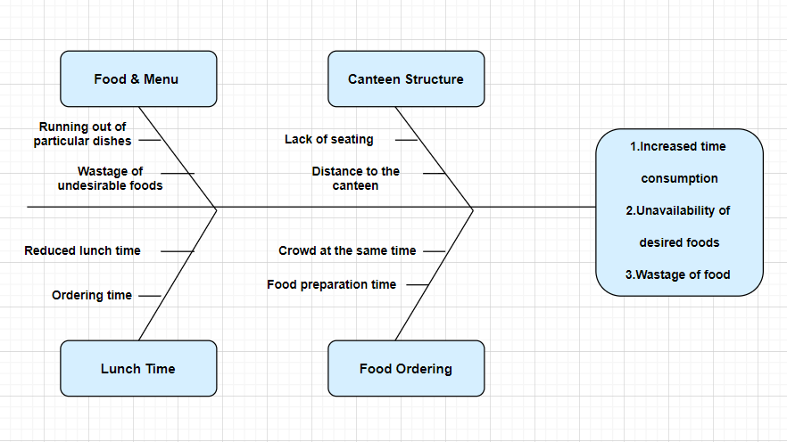

Task 3: Identify objectives of the new canteen ordering system

Advantages of the canteen ordering system
- The system would save considerable time to those employees who use the service
- It would increase the chance of them getting the food items they prefer
- This would improve both their quality of work life and their productivity
- The food wastage will be reduced
- This will reduce the cost
Objectives of the canteen ordering system
- Reduce canteen wastage by 30% within 6 months following first release
Scale: Value of food thrown away each month by examining the canteen inventory ( Previous - 25% wasted / Must plan for: Less than 15%)
- Reduce the canteen operating cost by 15% within 12 months, following initial release
- Increase average effective work time by 30 minutes per employee per day, within 3 months
- By making the ordering process automated and by delivering the food to the user’s workstation , the canteen will be able to operate with lesser manpower.

Task 4 : Create as-is and future process map (using flowcharts). You can use any of the popular tools in the market like Microsoft Visio, Lucid Chart, Creately, Pidoco, or Balsamiq

Existing System :
The existing system, data collected and understanding of wastage are depicted using the below process flow
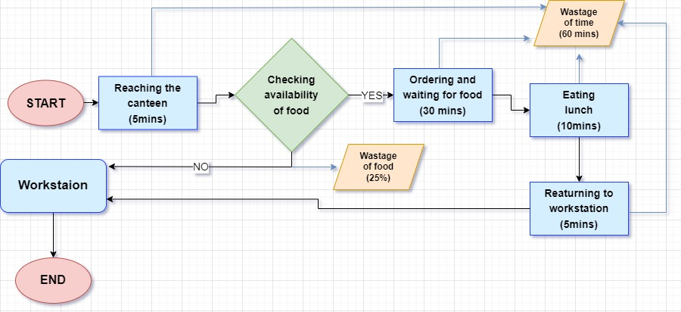
Proposed System :
The Future State system has been depicted using the below flow diagram:
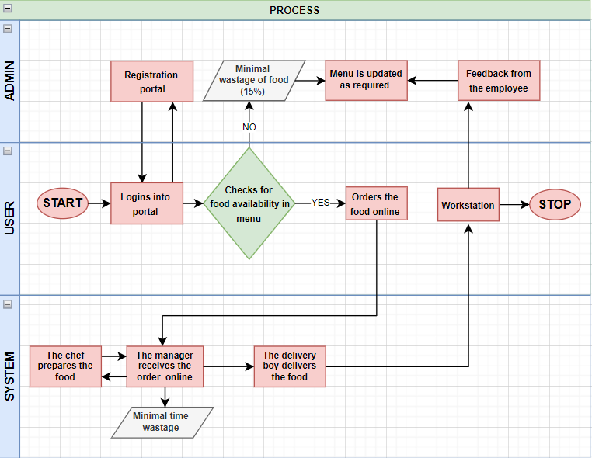
Task 5 - As a Business Analyst working on this project, find out the scope of the Canteen Ordering System. To find the scope you can use the case diagram (UML) or context diagram for the same.
Illustrated below is a context diagram showing the interaction between various actors and functionalities expected from the Canteen Ordering System:

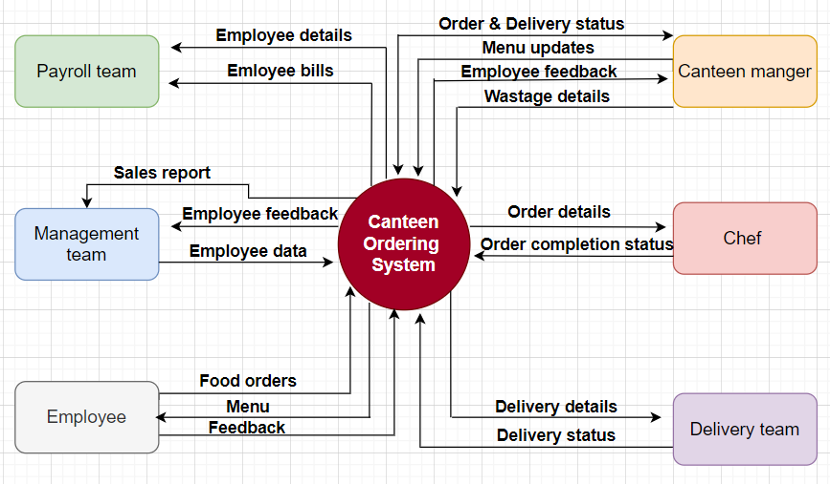

Task 6 - Write down the main features that need to be developed.
Listed below are the primary features that need to be developed within this solution system;

- To have up to date menu of all the dishes available in the canteen for the day along with its prices in the Food Ordering web-page
- To have a time limit for ordering food online (11am) to facilitate the canteen team with time to prepare sufficient food based on the orders
- To be able to update the menu by the canteen manager himself
- To be able to edit the orders as per wish before checking out in the web page
- To be able to take inventory of all orders from users by the canteen manager to get the orders prepared
- To be able to submit feedback on the food and services on the web page by the users after experiencing
- To be able to update order completion status by the delivery team
- To have the payment of dishes ordered by the employees to be deducted from their monthly salary by the payroll team. To facilitate the users to enroll for payment deduction with the payroll department

Task 7 - Write the in-scope and out-of-scope items for this software

In scope items:
- Employee registration and access
- Updated menu
- Order editing before checkout
- Payment deduction from the salary by payroll team
- Order cart
- Feedback on food and service
- Food delivery to workstation
- Access via application and website
- Order status tracking
- Submission of sales report
- Extraction of wastage report
- Alteration of menu based on feedback

Out scope items:
- Cancellation of order after checkout
- Refund on canceled orders
- Ordering facility beyond time limit
- Payment on spot
- Usage of web page beyond time limit or excess user access
- Chef team management
- Food supplier details
- Out of stock control

TASK 8: Draw an activity diagram for the system

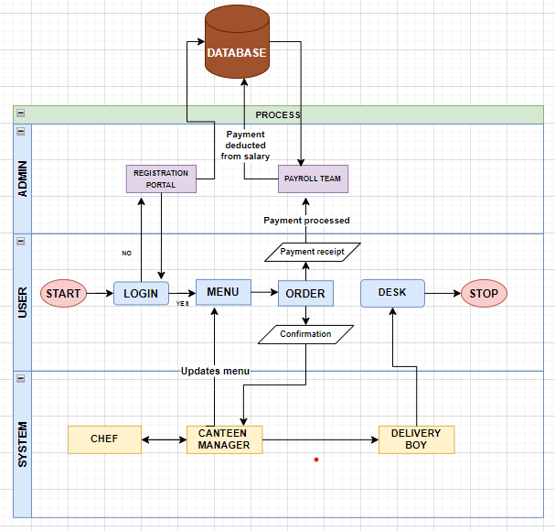

Task 9 - Draw an ER diagram of the system

Below ER diagram explains the relationships between the various entities and data sets:

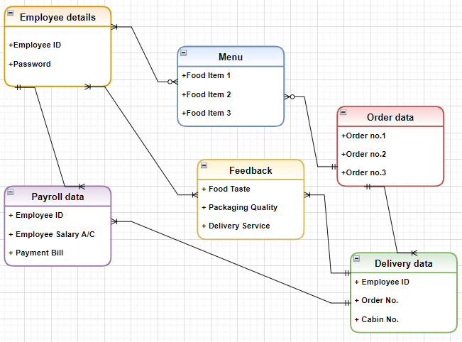

Task 10: Business Requirements (Functional and Non-functional)
The following are the business requirements:

- To reduce the 60 minutes spent by employees for having lunch
- To provide employees with food of their choice
- To reduce canteen food wastage by 30% min within 6 months, following the first release
- To reduce canteen operating costs by 15% within 12 months, following the initial release
- To increase average effective work time by 30 minutes per employee per day, within 3 months
- To automate the ordering process and deliver food to the user’s workstation
- To generate dynamic reports for better decision making

Functional Requirements:

- An online web portal/ mobile application is required to be developed, to automate canteen food ordering.

- Employees can select and order lunch they would like to eat from the list of dishes till 11 am and can edit any time before checking out

- Once the order is confirmed and the user has checked out, they will not be able to cancel or edit the order.

- The menu will be created and updated regularly by the canteen manager.

- The canteen manager will be able to view the orders placed and request delivery to the employee’s workstation.

- The lunch shall be delivered to the employee’s desk by a delivery boy, post which he will then be able to close the online customer order.

- The customer should be able to submit their feedback if he/she does not like any food item or is not happy with the delivery system.

- The payment for orders shall be managed by the payroll systems at the end of the month by calculating the total number of dishes ordered by each employee. The system shall deduct that amount from the employee’s salary.

MIS reports of different areas shall be developed for management:

- Most popular dishes report
- Number of employees using the system report
- Satisfaction rate of the employees’ report based on feedback submitted
- Sales for each day report
- Total monthly earnings report
- Order forecasting report

Non - functional Requirements

- System Requirement: The web pages should be light and render fast, and the system should be able to support a volume of 1500 employees ordering

- Usability: The screens should be self–explanatory and user–friendly.

- Environments: The program shall be created and maintained in Java, as it will not change over time and requires a little maintenance on the code.

Task 11 - Draw wireframes or mock screens for any two of the features namely Menu Creation and any other feature as deemed fit by the student. (Use the technique prototyping or wire framing that is taught in the Training). You can use any of the wireframing tools like Microsoft PowerPoint, Microsoft Word, Balsamiq, Sketch, Adobe XD, Adobe Illustrator, Figma, UXPin, InVision Studio, InVision Freehand, or Moqups.

